Activity | Data Type
Number of beatings from Wife | Discrete
Results of rolling a dice | Discrete
Weight of a person | Continuous
Weight of Gold | Continuous
Distance between two places | Continuous
Length of a leaf | Continuous
Dog's weight | Continuous
Blue Color | nominal
Number of kids | Discrete
Number of tickets in Indian railways | Discrete
Number of times married | Discrete
Gender (Male or Female) | nominal
Q1) Identify the Data type for the Following:

Q2) Identify the Data types, which were among the following
Nominal, Ordinal, Interval, Ratio.
Data | Data Type
Gender | Nominal
High School Class Ranking | Ordinal
Celsius Temperature | Interval
Weight | Ratio
Hair Color | Nominal
Socioeconomic Status | Ordinal
Fahrenheit Temperature | Interval
Height | Ratio
Type of living accommodation | Nominal
Level of Agreement | Ordinal
IQ(Intelligence Scale) | Ratio
Sales Figures | Ratio
Blood Group | Nominal
Time Of Day | Interval
Time on a Clock with Hands | Interval
Number of Children | Ratio
Religious Preference | Nominal
Barometer Pressure | Interval
SAT Scores | Interval
Years of Education | ratio

Q3) Three Coins are tossed, find the probability that two heads and one tail are obtained?
Solution: 3 coins are tossed, therefore outcomes : 3*2=8
(h=head ,t=tail) hhh, ttt,hht,hth,thh,tth,tht,htt
There are 3 outcomes which has 2 heads and 1 tail, they are: hht,hth,thh
The possibility of getting 2 heads and 1 tail is ½
(½) *( ½) *( ½)= 1/8
Probability= (1/8)+(1/8)+(1/8)
= 3/8

Q4) Two Dice are rolled, find the probability that sum is
- Equal to 1
- Less than or equal to 4
- Sum is divisible by 2 and 3
Solution: each die has 6 faces therefore possibility outcomes is 6*6=36.
a)probability that sum is equal to 1=1/36
there is only one possible outcome.
b)probability that sum is less than or equal to 4 is(1,1),(1,2),(1,3),(2,1),(2,2),(3,1)
there are 6 possible outcomes,
therefore 6/36=1/6.
c)sum is divisible by 2 and 3: (1,5),(2,4),(3,3),(1,5),(4,2),(6,6)
probability is 6/36=1/6.
Q5) A bag contains 2 red, 3 green and 2 blue balls. Two balls are drawn at random. What is the probability that none of the balls drawn is blue?

Solution: The combination of non blue balls are:- (R,R),(R,G),(G,G)
Number of possible outcomes=7
Total combination in 7 balls: 7*3=21
Probability=(number of possible outcomes)/(total combination )
=7/21
=1/3
Therefore there is 1/3 probability of non blue balls.

Q6) Calculate the Expected number of candies for a randomly selected child
Below are the probabilities of count of candies for children (ignoring the nature of the child-Generalized view)
CHILD | Candies count | Probability
A | 1 | 0.015
B | 4 | 0.20
C | 3 | 0.65
D | 5 | 0.005
E | 6 | 0.01
F | 2 | 0.120
Child A – probability of having 1 candy = 0.015.
Child B – probability of having 4 candies = 0.20
Solution: Expected number of candies=candies count * probability
=(1*0.015)+(4*0.20)+(3*0.65)+(5*0.005)+(6*0.01)+(2*0.120)
=0.015+0.80+1.95+0.025+0.06+0.24
=3.105
Therefore, expected number of candies for a randomly selected child is 3.105.

Q7) Calculate Mean, Median, Mode, Variance, Standard Deviation, Range & comment about the values / draw inferences, for the given dataset
- For Points,Score,Weigh>
Find Mean, Median, Mode, Variance, Standard Deviation, and Range and also Comment about the values/ Draw some inferences.
Use Q7.csv file
Solution: First arrange the dataset in increasing order,
Mean:
The mean is the average of the data values.
Mean of Points: (Sum of Points) / (Number of Data Points)
:115.09/32
:3.596
Mean of Score: (Sum of Score) / (Number of Data Score)
:102.95/32
:3.217
Mean of Weigh: (Sum of Weigh) / (Number of Data Weigh)
:571.16/32
:17.848
Median:
The median is the middle value when the data is arranged in ascending order. If there is an even number of data points, the median is the average of the two middle values.
Median of Points: find the middle value.
:3.695
Median of Score: find the middle value.
:3.32
Median of Weigh: find the middle value.
:17.71
Mode:
The mode is the data value that appears most frequently.
Mode of Points: No unique mode.
Mode of Score: No unique mode.
Mode of Weigh: No unique mode.

Variance:
Variance measures how data points vary from the mean.
Variance of Points: (Σ(Points - Mean of Points)^2) / (Number of Data Points - 1)
:0.265
Variance of Score: (Σ(Score - Mean of Score)^2) / (Number of Data Points - 1)
:0.956
Variance of Weigh: (Σ(Weigh - Mean of Weigh)^2) / (Number of Data Points - 1)
:3.193

Standard Deviation:
Standard deviation is the square root of variance and measures the average distance between data points and the mean.
Standard Deviation of Points ≈ √0.265≈ 0.514
Standard Deviation of Score ≈ √0.956 ≈ 0.977
Standard Deviation of Weigh ≈ √3.193 ≈ 1.786

Range:
Range measures the spread between the minimum and maximum values in the dataset.
Range of Points: Max(Points) - Min(Points) ≈ 4.93 - 2.76 ≈ 2.17
Range of Score: Max(Score) - Min(Score) ≈ 5.424 - 1.513 ≈ 3.911
Range of Weigh: Max(Weigh) - Min(Weigh) ≈ 22.9 - 14.5 ≈ 8.4
Q8) Calculate Expected Value for the problem below
- The weights (X) of patients at a clinic (in pounds), are
108, 110, 123, 134, 135, 145, 167, 187, 199
Assume one of the patients is chosen at random. What is the Expected Value of the Weight of that patient?
Solution:
Sum of values= 108 + 110 + 123 + 134 + 135 + 145 + 167 + 187 + 199
=1308
Total number of values=9
Expected value=sum of values/total number of values
=1308/9
145.33

Q9) Calculate Skewness, Kurtosis & draw inferences on the following data
Cars speed and distance
Use Q9_a.csv
Solution:
Skewness is a statistical numerical method to measure the asymmetry of the distribution or data set.
Formula to find skewness : ∑Ni=1(Yi−Y¯)3/Ns3
Mean of speed=15.4
Skewness of speed=-0.11751(close to zero)
This indicates that the data is approximately symmetrically distributed.
Mean of distance=42.94
Skewness of distance=0.8068
This indicates that the data is positively skewed, meaning it has a tail on the right side.
Kurtosis is a numerical method in statistics that measures the sharpness of the peak in the data distribution.
Formula to find kurtosis : ∑Ni=1(Yi−Y¯)4/Ns4
Kurtosis of speed=-0.50899
Kurtosis of distance=0.40505

SP and Weight(WT)
Use Q9_b.csv
Skewness of sp=1.61145
Skewness of weight=0.6147
Kurtosis of sp=2.97732
Kurtosis of weight=0.95029

Q10) Draw inferences about the following boxplot & histogram

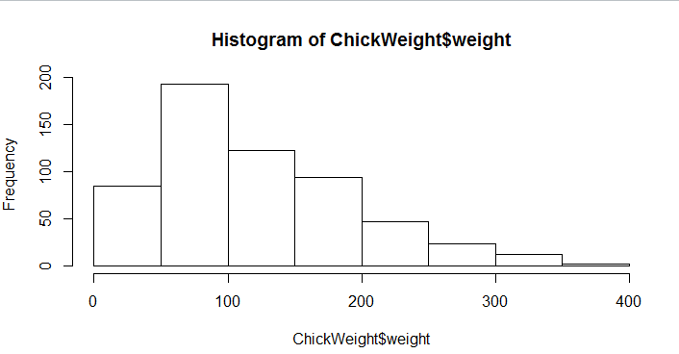
Answer:
- Data in histogram is positive skewed.
- Most frequency of chick weight is 50 to 150.

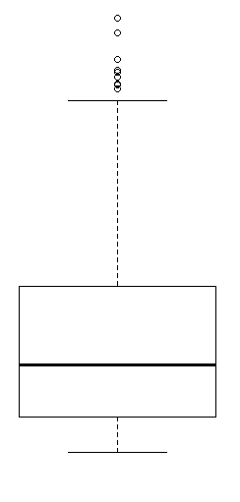
Answer:
1. Data in histogram is positive skewed.
2. Most frequency of chick weight is 50 to 150.
3. data in boxplot has outliers in upper side.
4. data in boxplot is has right tail.

Q11) Suppose we want to estimate the average weight of an adult male in Mexico. We draw a random sample of 2,000 men from a population of 3,000,000 men and weigh them. We find that the average person in our sample weighs 200 pounds, and the standard deviation of the sample is 30 pounds. Calculate 94%,98%,96% confidence interval?
Solution:
The formula is:
Confidence Interval=Sample Mean±((Z*Standard Deviation)/square root of n)
- For 94% confidence interval
Z=1.88
=200±((1.88*30)/square root 2000)
=198.03
2. For 98% confidence interval
Z=2.33
=200±((2.33*30)/square root 2000)
=197.56
3.For 96% confidence interval
Z=1.75
=200±((1.75*30)/square root 2000)
=198.18

Q12) Below are the scores obtained by a student in tests
34,36,36,38,38,39,39,40,40,41,41,41,41,42,42,45,49,56
- Find mean, median, variance, standard deviation.
- What can we say about the student marks?

Solution:
Mean=41
Median=40.5
Variance=25.52
Standard deviation=5.05

Q13) What is the nature of skewness when mean, median of data are equal?
Answer: when mean and median of data are equal then data is symmetrical.
Q14) What is the nature of skewness when mean > median ?
Answer: when mean > median then skewness is positive.
Q15) What is the nature of skewness when median > mean?
Answer: when median > mean then skewness is negative.

Q16) What does positive kurtosis value indicates for a data ?
Answer: positive kurtosis shows data has taller tails and sharper peak.
Q17) What does negative kurtosis value indicates for a data?
Answer: Negative Kurtosis indicates that data has lighter tails and wider peak

Q18) Answer the below questions using the below boxplot visualization.
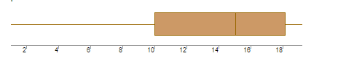
What can we say about the distribution of the data?
Answer: it is non-symmetrical distributed.
What is nature of skewness of the data?
Answer: it is negative skewed.
What will be the IQR of the data (approximately)?
Answer: IQR of data is 8.

Q19) Comment on the below Boxplot visualizations?
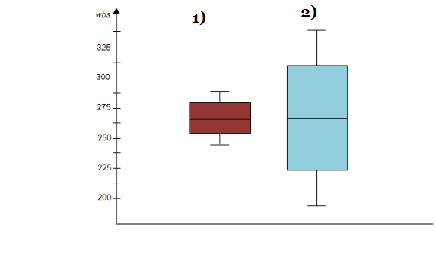
Draw an Inference from the distribution of data for Boxplot 1 with respect Boxplot 2.
Answer: Boxplot 1 has negative kurtosis.
Boxplot 2 has positive kurtosis.
Q 20) Calculate probability from the given dataset for the below cases

Data _set: Cars.csv
Calculate the probability of MPG of Cars for the below cases.
MPG <- Cars$MPG
  - P(MPG>38)
  - P(MPG<40)
c. P (20<MPG<50)
solution:
MPG <- Cars$MPG
a.P(MPG>38) --51.76%
b.P(MPG<40) ---- 0.527461
c. P(20<MPG<50) ---57%

Q 21) Check whether the data follows normal distribution
- Check whether the MPG of Cars follows Normal Distribution
Dataset: Cars.csv
Answer: it follows normal distribution

- Check Whether the Adipose Tissue (AT) and Waist Circumference(Waist) from wc-at data set follows Normal Distribution
Dataset: wc-at.csv
Answer: it does not follows normal distribution

Q 22) Calculate the Z scores of 90% confidence interval,94% confidence interval, 60% confidence interval
Solution: Confidence Interval=Sample Mean±((Z*Standard Deviation)/square root of n)

Q 23) Calculate the t scores of 95% confidence interval, 96% confidence interval, 99% confidence interval for sample size of 25
Q 24) A Government company claims that an average light bulb lasts 270 days. A researcher randomly selects 18 bulbs for testing. The sampled bulbs last an average of 260 days, with a standard deviation of 90 days. If the CEO's claim were true, what is the probability that 18 randomly selected bulbs would have an average life of no more than 260 days
Hint:
rcode pt(tscore,df)
df degrees of freedom

